Early Indicators of Long-Term Player Engagement in Steam Games

Thesis Paper for I-492 Project

by

Joshua Cochran

Advisor
Dr. Sridhar Ramachandran

Table of Contents
I. Abstract 3
II. Introduction 3
III. Literature Review 5
IV. Methods 7
V. Results 9
VI. Discussion 15
VII. Conclusion 17
VIII. Future Directions 17
List of References 17
Link to the References 19

I. Abstract
This study investigates which early signals best predict long-term player engagement in games released on the Steam platform. Understanding player engagement is important for developers and publishers because sustained engagement often determines a game’s long-term success. The primary hypothesis of this study is that early behavioral signals, such as early playtime, player reviews, and recommendations, can meaningfully predict lifetime engagement.

The analysis uses a dataset containing game metadata and player activity metrics for Steam games released between 2023 and 2024. Key variables include early playtime, peak concurrent players, player reviews, recommendations, and genre classifications. Continuous engagement variables were log-transformed to address severe right skew (skewness values of 51.7 and 262.9 for early and lifetime playtime, respectively), and genre fields were encoded as binary indicators. Multiple regression models were used to examine relationships between early indicators and lifetime playtime. Additional validation methods included regularized regression, time-based validation, and genre interaction analysis.

The results show that community engagement metrics, particularly player recommendations and total review volume, are the strongest predictors of long-term playtime. Early engagement shortly after release is also a strong predictor of sustained player activity. Interaction analysis further reveals that early engagement has stronger effects for certain genres, including Free-to-Play and Casual games.

These findings suggest that early player activity and community response are key signals of long-term engagement in digital game ecosystems.

II. Introduction
Digital distribution platforms such as Steam have transformed how video games are released, discovered, and played. With thousands of games launching each year, developers face increasing uncertainty about which titles will achieve sustained player engagement. Long-term engagement is particularly important because it influences community growth, player retention, and revenue generation.

One of the key challenges in the gaming industry is identifying early indicators of long-term success. Games often experience strong activity immediately after launch, but only a subset maintain sustained engagement over time. Understanding which early signals reliably predict long-term engagement could help developers better evaluate the potential success of a game shortly after release.

This study examines whether early player behavior and community response can predict long-term engagement for Steam games. Specifically, the analysis investigates whether early playtime, review activity, recommendations, and genre characteristics are associated with lifetime playtime.

The central hypothesis of this research is that early engagement signals, particularly player activity and community feedback, are strong predictors of long-term player engagement. By identifying these relationships, this study aims to provide insight into how early player behavior reflects the long-term success of games within digital game ecosystems.

This study contributes to the growing literature by directly comparing the predictive power of behavioral engagement signals against community metrics and static game attributes within a single regularized regression framework, using the largest publicly available Steam dataset (122,611 games) and testing generalizability through time-based validation. Using large-scale platform data from Steam, this analysis evaluates which early signals most strongly predict long-term engagement outcomes. The findings provide practical insights for developers and publishers seeking to evaluate game performance shortly after release.

III. Literature Review
Research on player engagement in digital games has expanded significantly as large-scale platform data has become increasingly accessible. Digital distribution platforms such as Steam provide publicly available information on thousands of games, allowing researchers to study engagement patterns across large and diverse sets of titles. Unlike traditional game studies that rely on surveys or case studies, platform-based datasets enable researchers to examine behavioral signals such as playtime, player counts, reviews, and recommendations across entire ecosystems of games.

However, engagement is not directly observable in these datasets. Instead, it must be inferred using proxy indicators derived from aggregated platform data. As a result, existing research varies in how engagement is defined and measured. Some studies focus on behavioral depth, such as playtime, while others emphasize visibility-related indicators such as concurrent players or social signals such as reviews and recommendations.

The literature can broadly be organized along two themes: how engagement is measured using platform data, and which factors are associated with long-term engagement outcomes.
Measuring Player Engagement Using Platform Data
A large portion of the literature focuses on how engagement can be approximated using platform-level behavioral metrics. One of the most widely used measures is playtime, which captures how long players spend interacting with a game. O’Neill et al. (2016) examined Steam user behavior at large scale and found that playtime distributions follow heavy-tailed patterns, meaning that a small number of games account for a disproportionate share of total activity. Because of this skewness, average playtime can be misleading when used to describe “typical” engagement.
Subsequent studies have highlighted that playtime reflects meaningful behavioral depth but must be interpreted alongside contextual signals. Byers (2024) shows that players frequently reference playtime in reviews when discussing the value or satisfaction derived from a game. Similarly, Brodschneider and Pirker (2023) demonstrate that playtime can respond to social feedback, with review sentiment influencing subsequent play activity. These findings suggest that playtime captures behavioral engagement while also interacting with social signals within the platform ecosystem.
Another approach measures engagement using concurrent player counts or popularity signals. Studies using player-count data emphasize visibility and momentum rather than behavioral depth. For example, Wirawan and Kusuma (2024) used time-series modeling to predict player counts for top Steam games and found that recent historical activity strongly influences future player counts. Similarly, Hu (2024) demonstrated that popularity signals on Steam can be predicted using machine learning models trained on structured game metadata.
These studies highlight that concurrent user metrics often reflect attention and visibility rather than sustained engagement. Because concurrent player counts frequently spike during launch periods or marketing events, they capture short-term momentum rather than long-term behavioral depth.
A third category of engagement measures relies on reviews, ratings, and recommendations. These indicators capture player sentiment and perceived game quality rather than direct behavioral activity. Large-scale analyses of Steam reviews have shown that review behavior varies significantly based on sentiment and timing. For example, Guzsvinecz and Szűcs (2023) found that negative reviews tend to appear earlier than positive reviews, suggesting that review dynamics reflect emotional responses and player expectations.
Other studies treat review signals as predictors of engagement rather than engagement measures themselves. Research by Li et al. (2022) and Chen et al. (2023) demonstrates that review sentiment and timing can influence player behavior and engagement trajectories. These findings suggest that social feedback affects engagement indirectly by shaping player perceptions and expectations.
Together, these studies show that engagement on digital platforms is multi-dimensional. Behavioral depth, visibility signals, and social feedback all capture different aspects of player activity. As a result, no single metric fully represents engagement outcomes.

Factors Associated with Long-Term Engagement
Beyond measuring engagement, a growing body of research examines which factors are associated with sustained player activity. These studies typically analyze large platform datasets using statistical modeling or machine learning techniques.
One group of studies emphasizes platform visibility and discoverability as key drivers of engagement. Zhang et al. (2023) analyzed early visibility indicators such as player activity and wish list counts and found that early platform exposure can predict longer-term performance. Similarly, Kumar and Li (2022) demonstrate that algorithmic recommendation systems significantly influence user engagement by shaping which products receive attention within digital marketplaces.
Other research focuses on reviews and social feedback as predictors of engagement outcomes. Li et al. (2022) show that positive review sentiment correlates with longer usage duration in digital entertainment platforms. Chen et al. (2023) further demonstrate that early negative reviews can significantly influence long-term engagement trajectories by shaping player expectations during the early stages of a product’s lifecycle.
A third group of studies examines pricing strategies and release characteristics. Research by Liu et al. (2022) finds that lower prices and promotional discounts increase short-term adoption but do not necessarily translate into sustained engagement. Similarly, Martins et al. (2023) show that players who acquire games through deep discounts often exhibit lower median playtime than full-price purchasers. Other studies suggest that release timing and competition density may also influence long-term engagement patterns (Wang & Chen, 2024).
Taken together, these findings suggest that long-term engagement is influenced by a combination of behavioral, social, and platform-level factors. Visibility affects whether players encounter a game, reviews shape expectations and perceived value, and pricing strategies influence adoption decisions. However, sustained engagement ultimately depends on deeper behavioral interactions between players and games.

Critical Evaluation of Literature
The existing literature provides important insights into how engagement can be studied using large-scale platform data. One major strength of this research is the ability to analyze thousands of games simultaneously, allowing researchers to identify broad patterns that extend beyond individual titles.
However, several limitations remain. Many studies rely heavily on average-based metrics despite the highly skewed distribution of engagement data. Because a small number of games account for a large share of activity on platforms such as Steam, average values can produce misleading conclusions about typical engagement patterns.
Another limitation is that engagement is often treated as a single outcome variable, even though different measures capture different dimensions of player behavior. Playtime reflects behavioral depth, player counts capture attention and momentum, and reviews reflect sentiment and perception. Treating these metrics interchangeably can obscure important differences in what they represent.
Finally, while many studies emphasize predictive modeling, fewer focus on interpretability or on explaining how engagement signals should be understood within the broader context of platform ecosystems.

Research Gap
Despite the growing use of Steam datasets in engagement research, there is still limited work that directly compares early behavioral signals and long-term engagement outcomes across large numbers of games. Relatively few studies center robust engagement metrics that account for the highly skewed nature of playtime data.
This study addresses that gap by focusing on median lifetime playtime as a measure of long-term engagement, supported by complementary indicators such as peak concurrent players and review activity. By examining how early behavioral signals relate to long-term outcomes, the study aims to provide a clearer and more interpretable understanding of player engagement dynamics on digital game platforms.

IV. Methods
Dataset

This study uses a dataset containing metadata and player engagement metrics for games available on the Steam platform. The dataset consists of 122,611 games and 39 variables, including release information, player activity metrics, review counts, recommendations, and genre classifications. These variables provide a combination of behavioral engagement indicators and game metadata used to analyze predictors of long-term player engagement.

Key engagement variables include:

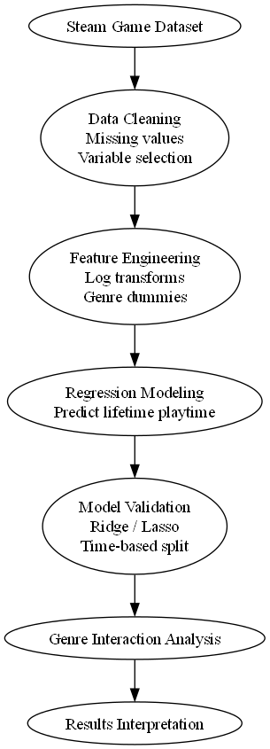
- Average playtime in the first two weeks
- Average lifetime playtime
- Peak Concurrent Players
- Total player reviews
- Player recommendations

Several preprocessing steps were performed before modeling. Missing values in non-core variables were excluded; all core modeling variables (average_playtime_two_weeks, average_playtime_forever, peak_ccu, positive, negative, recommendations) contained zero missing values. Continuous engagement metrics were log-transformed using log(x+1) to address extreme right skew, skewness values of 51.7 for early playtime and 262.9 for lifetime playtime required transformation before regression modeling. Genre information was converted into binary indicator variables, retaining the 14 genres appearing in at least 500 games. A zero-inflation flag was also created to capture the structural distinction between games with no recorded early engagement (96.82% of the dataset) and games with measurable early player activity.

Tools

The analysis was conducted using Python with several standard data science libraries, including:

- pandas
- numpy
- scikit-learn
- statsmodels
- matplotlib

These tools were used for data cleaning, statistical modeling, and visualization.

Figure 6. Analytical workflow used in the study.
The analysis begins with Steam game metadata, followed by data cleaning and exploratory analysis. Feature engineering and regression modeling are used to examine predictors of lifetime playtime, with additional validation and genre interaction analysis to interpret results.

Procedures

A multiple linear regression model was used to estimate the relationship between early engagement signals and lifetime playtime.

- Exploratory Data Analysis (EDA) to understand variable distributions and identify relationships between early engagement and long-term playtime.
- Feature Engineering, including log transformations and creation of binary genre variables.
- Baseline Regression Modeling to examine how early indicators relate to lifetime playtime.
- Two-Stage Modeling, separating the prediction of early engagement from the prediction of lifetime playtime.
- Regularization Methods (Ridge and Lasso) to test coefficient stability.
- Time-Based Validation, where models were trained on earlier releases and tested on newer games to evaluate generalization.
- Genre Interaction Analysis, examining whether early engagement has stronger effects for certain genres.

Each modeling step was chosen to serve a specific validation purpose. Log transformations were applied because raw playtime distributions have skewness values above 50, which violates the linearity assumptions of OLS regression. Ridge and Lasso regularization were not expected to improve on the baseline but were included to test whether the feature set was stable, near-identical performance across all three models confirms it is. Time-based validation was used instead of random cross-validation because random splitting would allow the model to train on future games and test on past ones, which is not how predictions are made in practice. Genre interaction terms were added specifically to test whether the hypothesis holds uniformly across game types or varies by genre. These methods allow the study to both predict engagement and interpret the factors that influence it.

V. Results
Before presenting the modeling results, it is useful to examine the distribution of early engagement metrics in the dataset. Engagement metrics on digital platforms often exhibit highly skewed distributions, where a small number of games account for disproportionately large amounts of player activity. In this dataset, 96.82% of games record zero early playtime, a level of zero-inflation that shapes every subsequent modeling decision. Understanding this distribution is essential for interpreting both the transformation choices and the model's performance metrics.
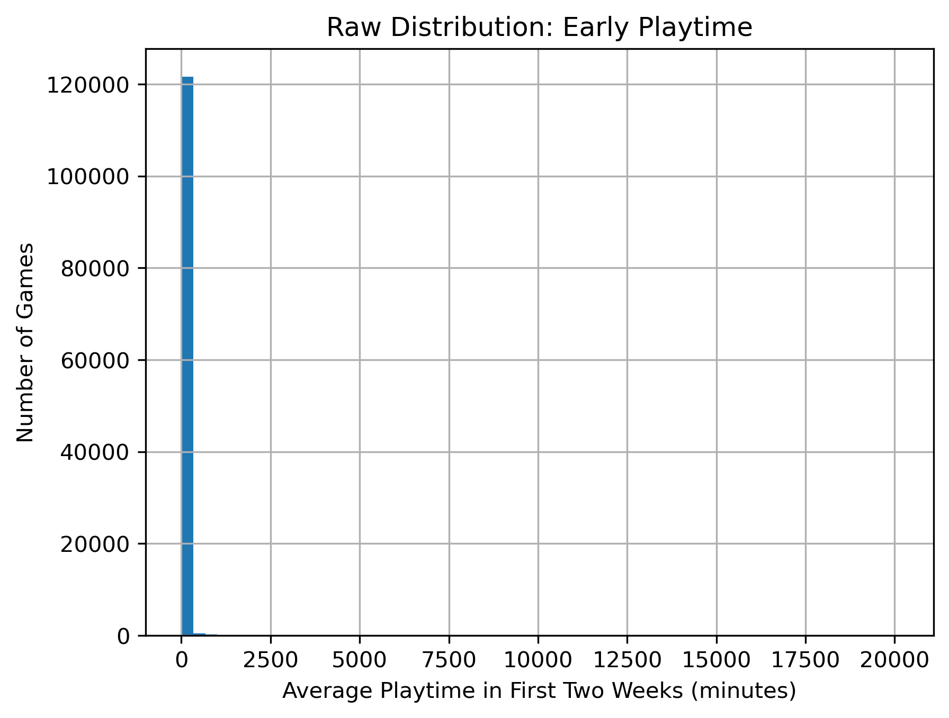

Figure 1. Distribution of early playtime across Steam games.
Most games receive very little early playtime, while a small number of titles achieve extremely high engagement levels. This heavy-tailed pattern motivates the use of log transformations in later analysis.

As shown in Figure 1, the distribution of early playtime is highly skewed.
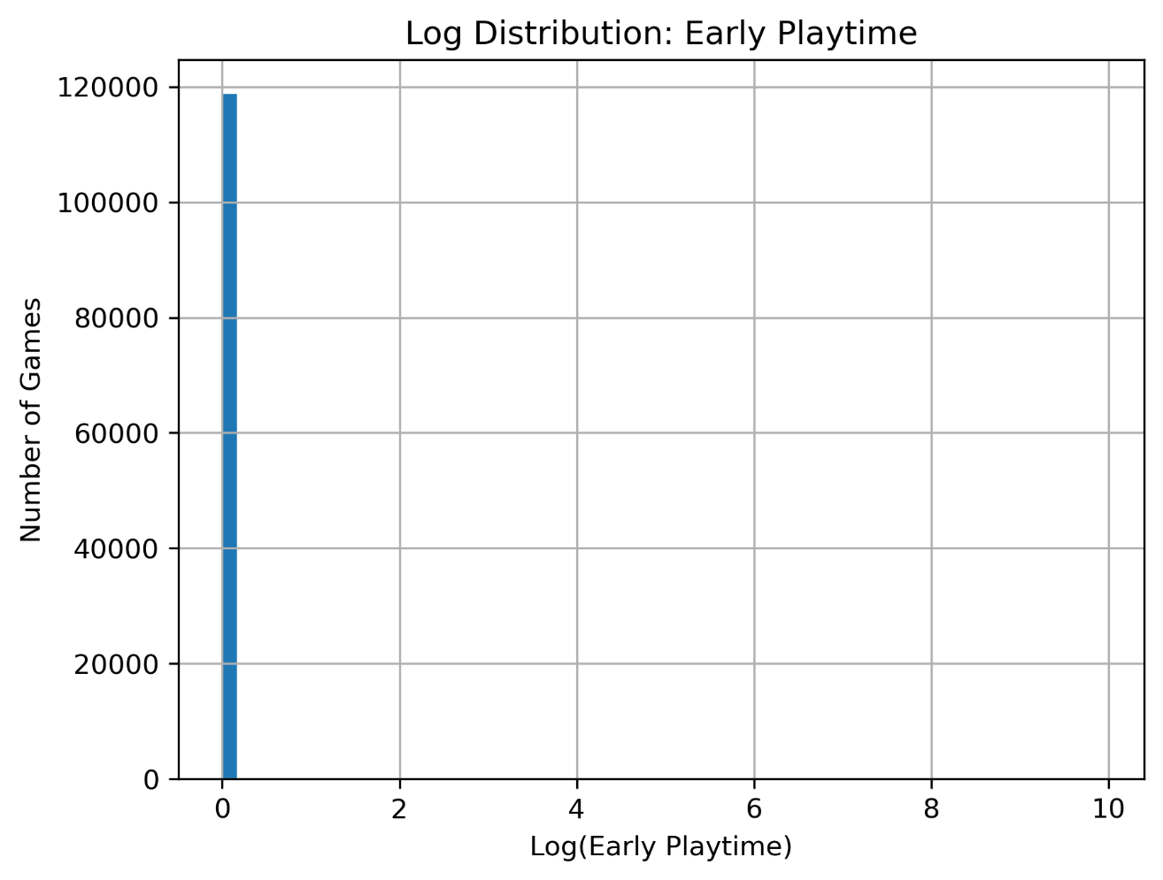

Figure 2. Log-transformed distribution of early playtime.
Applying logarithmic transformation reduces the skewness of the distribution, making the data more suitable for regression modeling.
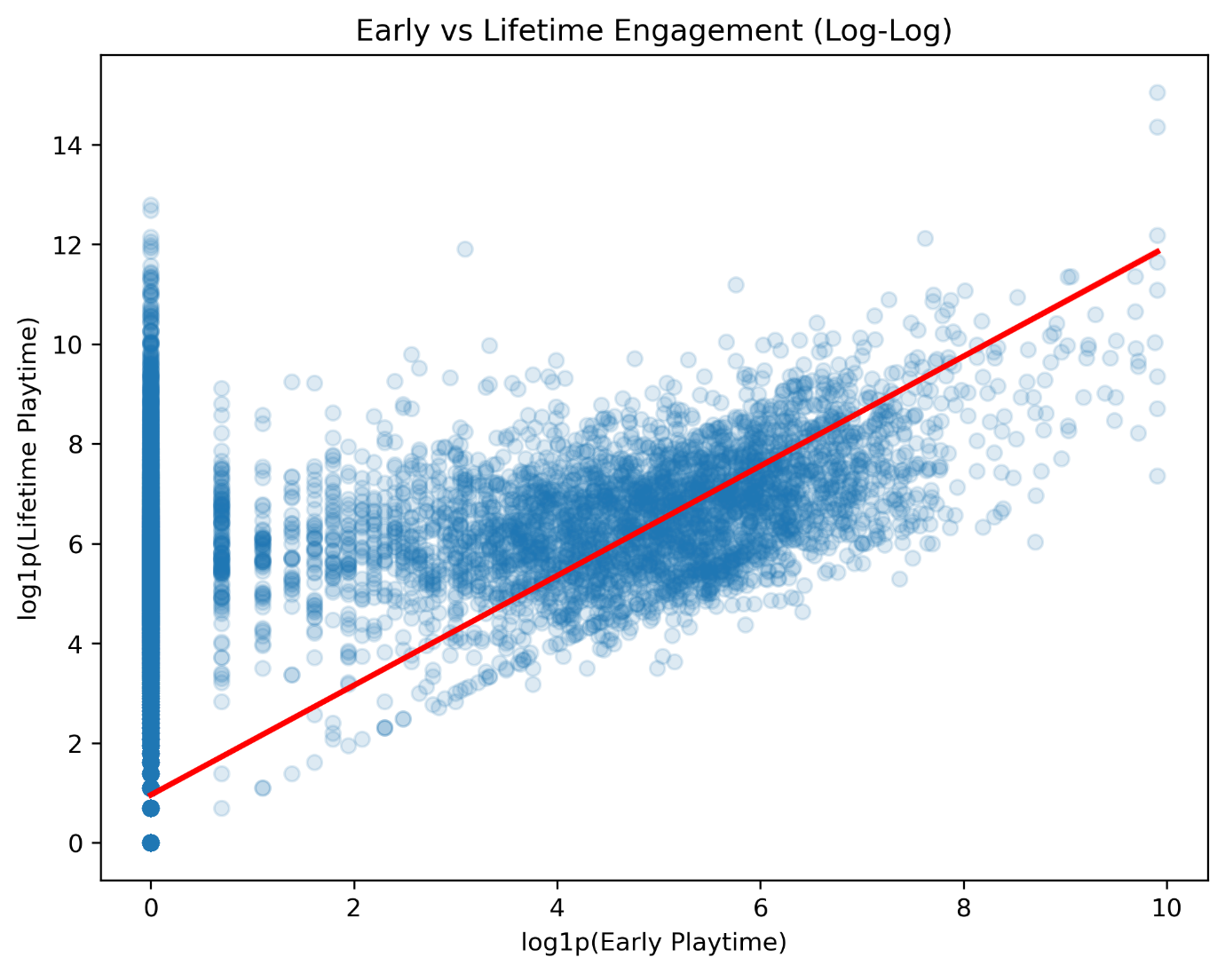
Figure 3. Relationship between early and lifetime playtime (log-log scale).
Games that generate higher early playtime tend to maintain higher lifetime engagement. The log transformation highlights the positive relationship across a wide range of engagement levels.

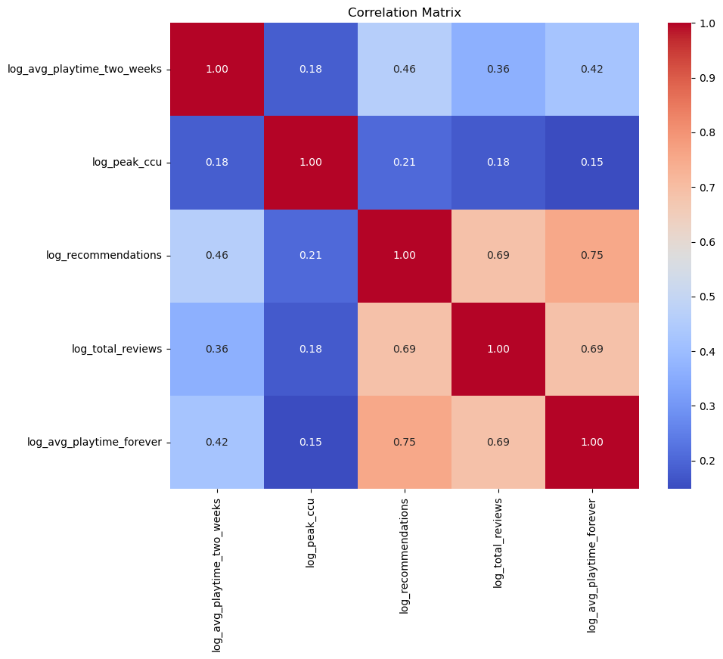

Heatmap 1. Bivariate correlations among key predictors and lifetime engagement (log scale).
Heatmap 1 above presents the bivariate correlations among all key predictors and the outcome variable on the log scale. Player recommendations show the strongest bivariate correlation with lifetime playtime (r=0.754), followed by total review volume (r=0.688). Early playtime (r=0.423) is the third strongest predictor in isolation. Notably, it substantially outperforms peak concurrent users (r=0.148), which captures launch visibility rather than behavioral engagement depth. The moderate correlation between recommendations and total reviews (r=0.687) indicates these variables are related but non-redundant; both were retained after confirming VIF values below 5 for all predictors.

The baseline regression model achieves an R² of 0.632 on a held-out test set (n=24,522 games), indicating that the combination of early behavioral signals and genre characteristics explains nearly two-thirds of the variation in long-term playtime. For behavioral data drawn from a platform where 97% of games record near-zero engagement, this represents strong predictive performance. The strongest individual predictors by raw (unstandardized) OLS coefficient are player recommendations (β=0.456), total review volume (β=0.296), and early playtime (β=0.199). When standardized to allow direct comparison across predictors with different scales, the ranking is consistent: recommendations (β≈0.48), total reviews (β≈0.26), and early playtime (β≈0.22), with early playtime ranking above peak concurrent users (β≈0.21) in both cases. Notably, early playtime contributes independently of community engagement metrics, its partial effect remains significant (p<0.001) after controlling recommendations and review counts, which directly supports the central hypothesis that early behavioral engagement carries predictive information beyond what static features or social signals alone can provide.

A robustness check comparing the full dataset model (R²=0.623) against a restricted model run only on the 3,898 games with non-zero early engagement (R²=0.453) confirms that the full-dataset result is partly driven by the model's ability to identify low-engagement games. Within the engaged subpopulation, where the zero/non-zero distinction is already resolved, the model still explains 45.3% of variation in long-term engagement magnitude. A strong result for predicting behavioral outcomes in this subset.
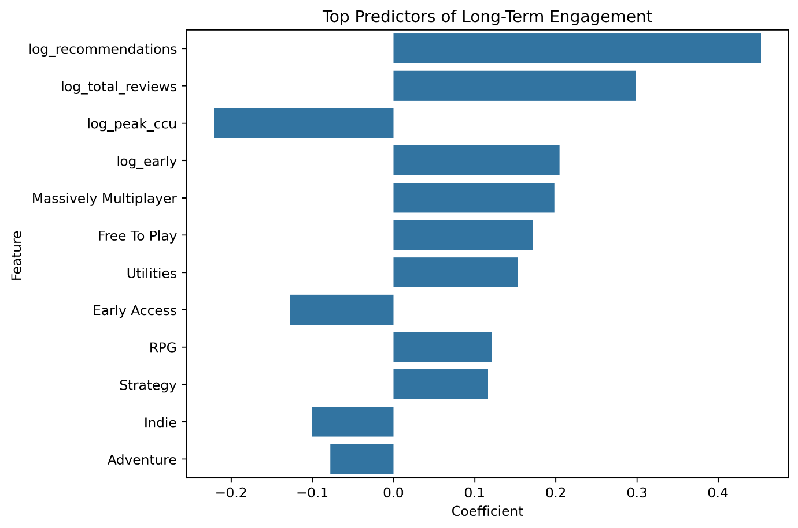

Figure 4. Top predictors of long-term engagement from the regression model.
Community engagement metrics such as player recommendations and review volume show the strongest relationships with lifetime playtime. Early engagement also contributes positively to long-term player activity.

The standardized coefficient chart (Figure 4) is particularly relevant to the central hypothesis: early playtime ranks as the third most important predictor overall, above peak concurrent users and all but two genre indicators. This confirms that early behavioral engagement carries independent predictive signals that are not simply captured by community metrics or static game attributes.

Time-based validation, training on games released before 2022 and testing on games released after, yields R²=0.521 and RMSE=1.929, compared to R²=0.623 on the random split. The 11-percent-point decline is meaningful and reflects two factors: newer games have had less time to accumulate lifetime playtime, and the year-parsing step required excluding 21,641 records with anomalous date fields, reducing the test set to 6,643 games. Despite these constraints, the model retains substantial predictive power on unseen future releases, and the feature rankings remain stable, log_recommendations and log_early remain the top behavioral predictors in the time-based model as well. Interaction analysis revealed that the effect of early engagement varies across genres. Importantly, the feature importance rankings remain stable, log_recommendations and log_early remain the top two behavioral predictors in the time-based model, confirming that the findings generalize in both direction and relative magnitude, not just overall fit.
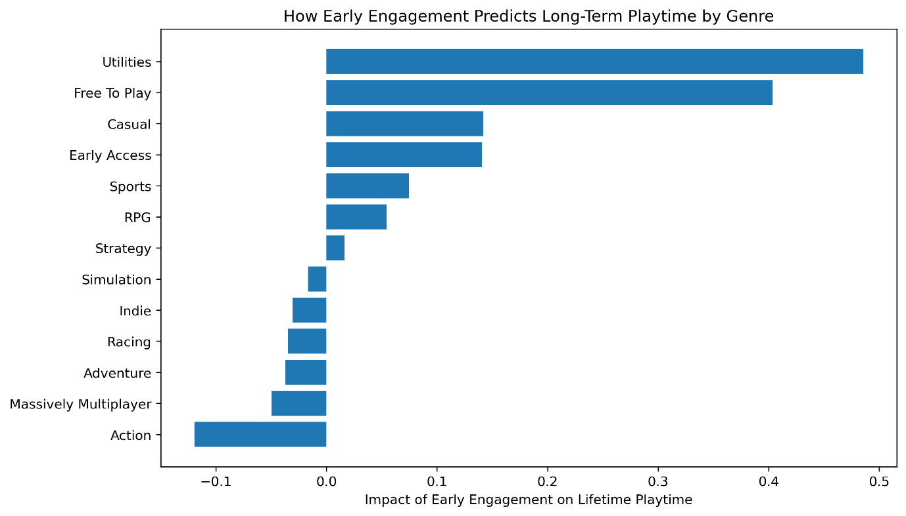
Figure 5. Interaction effects between early engagement and genre.
Early engagement has stronger predictive effects for some genres, including Free-to-Play and Casual games, while other genres show weaker relationships.

Early engagement had the strongest impact in Free-to-Play, Casual, Utilities, and Early Access games, suggesting that these genres rely heavily on early player activity to sustain long-term engagement.

VI. Discussion
The results provide clear support for the central hypothesis: early player engagement, measured by average playtime during the first two weeks after release, is a stronger predictor of long-term engagement than static game attributes such as genre or price. On the standardized scale, early playtime ranks as the third strongest predictor overall (β=0.22), outperforming peak concurrent users (β=0.21) and all genre indicators except Massively Multiplayer and Free to Play. Critically, early playtime's partial effect remains statistically significant after controlling for community engagement metrics, meaning it captures independent information about long-term engagement that recommendations and review count alone do not.

The dominant influence of player recommendations and review volume on long-term engagement suggests that community response plays a central role in sustaining player activity on digital platforms. These metrics likely reflect two related mechanisms. First, positive reviews and recommendations signal game quality to prospective players, increasing discovery and adoption over time. Second, as Kumar and Li (2022) demonstrate, algorithmic recommendation systems on digital marketplaces amplify the visibility of highly reviewed products, creating a reinforcing dynamic where early community engagement drives further exposure. The result is that community response is both a measure and an amplifier of long-term engagement. It reflects player satisfaction while also generating the platform visibility that sustains it. This sign reversal relative to the bivariate correlation (r=0.148) reflects statistical suppression: peak CCU co-varies with review signals, and once that shared variance is accounted for in the multivariate model, higher peak concurrency alone is associated with lower long-term engagement, consistent with games that generate burst attention without sustaining it.

A structural feature of this dataset requires careful attention in interpreting these results. Nearly 97% of Steam games record zero early playtime, meaning the full-dataset R²=0.632 partly reflects the model's ability to identify this low-engagement majority. When the analysis is restricted to the 3,898 games that generate measurable early engagement, R² falls to 0.453, a drop that reflects the genuine difficulty of predicting engagement magnitude once the zero/non-zero distinction is resolved. For game developers, this distinction is practically important: the model's primary value is in identifying which games are likely to sustain player activity at all, rather than precisely predicting how much playtime a successful game will accumulate.

Genre interaction analysis reveals that the predictive value of early engagement is not uniform across game types. Free-to-Play games show one of the strongest interaction effects (β=0.40), consistent with the structural design of these titles. Because free-to-play games monetize through in-game purchases rather than upfront sales, sustaining player activity is both the business objective and the precondition for revenue generation. Early engagement in these games likely reflects genuine player investment, the willingness to spend time without a sunk-cost incentive, which may explain why it predicts long-term behavior more strongly than in paid titles. Similarly, Casual games show a strong interaction, possibly because this genre spans a wide range of quality levels and early engagement more reliably distinguishes genuinely engaging titles from those that attract curiosity but not sustained play.

Model diagnostic checks confirm the regression results are interpretable and well-specified. Residuals follow an approximately normal distribution in the central range, with heavy tails driven by the zero-playtime mass and a small number of extreme outlier games. The Q-Q plot confirms normality holds for the bulk of the distribution (approximately -2 to +2 standard deviations), supporting the validity of the coefficient estimates and p-values for most of the sample. Ridge and Lasso regularization produce results within 0.1% of the baseline on both R² and RMSE, confirming that the feature set is stable and that multicollinearity is not artificially inflating apparent predictor importance.

Several limitations of this study should be acknowledged. First, the dataset captures aggregated engagement metrics rather than individual player behavior. Predicting average playtime across all players of a game is a different task from predicting whether a specific player will remain engaged, and the findings should be interpreted at the game level rather than the player level. Second, the time-based validation reveals some degradation in performance for newer releases (R²=0.521 vs. 0.623), partly because games released after 2021 have had less time to accumulate lifetime playtime at the time of data collection. Third, while the genre interaction analysis identifies differential effects, it does not establish causality. Differences in monetization model, target audience, and game design co-vary with genre and may individually drive the observed patterns.

These findings are consistent with prior work highlighting the role of social signals and behavioral momentum in digital platform ecosystems (Li et al., 2022; Zhang et al., 2023; Kumar & Li, 2022). They extend this literature by demonstrating that early behavioral engagement, distinct from community metrics and static attributes, contributes independently to long-term outcomes. For developers and publishers, this suggests that the first two weeks following a game's release represent a critical window: community response during this period is the strongest predictor of sustained engagement, and early player activity provides a complementary and non-redundant signal about a game's long-term potential.

VII. Conclusion
This study examined whether early signals of player activity can predict long-term engagement for Steam games, using a dataset of 122,611 titles and a multi-method regression framework. The central hypothesis that early engagement signals are stronger predictors of long-term activity than static game attributes was supported. Early playtime ranks above peak concurrent users and most genre indicators on the standardized coefficient scale, and its partial effect remains significant after controlling for community engagement metrics.

Player recommendations and review volume emerge as the strongest overall predictors, reflecting both player satisfaction and the dynamics that sustain engagement over time. Genre interaction analysis adds nuance: the predictive value of early playtime is strongest for Free-to-Play and Casual games, genres whose engagement patterns are most directly linked to sustained behavioral investment. Model diagnostics confirm the results are robust, Ridge and Lasso regularization match the baseline within 0.1%, and time-based validation confirms the relationships generalize to games released after the training period.

These findings suggest that developers and publishers can use early behavioral and community signals, available within the first weeks of a game's release, to make more informed assessments of long-term engagement potential. Games that generate strong early playtime and positive community response shortly after launch are substantially more likely to sustain player activity over time. Specifically, the model predicts that a game moving from zero to one log unit of additional early playtime (approximately 1.7x increase in early minutes) is associated with a 0.199-unit increase in log lifetime playtime, holding other factors constant. For the industry, this points to the first two weeks post-release as a critical evaluation window, one where observable behavioral signals already carry meaningful predictive information about a title's long-term trajectory.

VIII. Future Directions
This study opens several directions for future research. The most significant extension would be the use of player-level data rather than game-level aggregates. The current analysis predicts average playtime across all players of a given title, which obscures individual retention dynamics. Access to player-level data would allow researchers to model whether specific players disengage, when they disengage, and which early signals best distinguish retained players from those who abandon a game shortly after starting.
A second direction involves reframing the prediction task as a classification problem. Rather than predicting continuous lifetime playtime, future work could define a binary threshold, for example, whether a game reaches the top quartile of lifetime engagement among its genre peers, and train models to predict which games will cross that threshold based on early signals. This framing may be more actionable for developers and publishers who need a clear signal about whether a game is on track for sustained success rather than a continuous estimate.

Third, time-series modeling could be used to track how engagement signals evolve across a game's full lifecycle rather than treating early and lifetime engagement as two static snapshots. Understanding how community response, playtime momentum, and genre effects shift over months or years after release would provide a richer picture of the engagement process.

Finally, future studies could examine how post-launch developer actions, such as major content updates, pricing changes, promotional discounts, and marketing campaigns, moderate the relationship between early engagement and long-term outcomes. The current analysis treats game characteristics as fixed at launch, but in practice developers actively intervene to shape engagement trajectories. Accounting for these interventions would improve both realism and the practical utility of engagement prediction models.

List of References
Brodschneider, T., & Pirker, J. (2023). On the influence of reviews on play activity on Steam: A statistical approach. Proceedings of the IEEE Conference on Games (CoG).
https://doi.org/10.1109/CoG57401.2023.10333235

Byers, A. (2024). Playtime, value, and player judgment on digital game platforms. Proceedings of the Digital Games Research Association (DiGRA) Conference.
https://dl.digra.org/index.php/dl/article/view/2263

Chen, Y., Wang, L., & Zhao, H. (2023). Early review dynamics and their impact on long-term engagement in digital platforms. Information & Management, 60(4), 103758.
https://doi.org/10.1016/j.im.2023.103758

Guzsvinecz, T., & Szűcs, K. (2023). Large-scale analysis of user reviews on Steam using natural language processing. Computers in Human Behavior, 139, 107511.
https://doi.org/10.1016/j.chb.2022.107511

Hu, Y. (2024). Predicting game popularity on Steam using machine learning techniques. In Proceedings of the International Conference on Data Science and Knowledge Engineering.
https://www.scitepress.org/Papers/2024/128538/128538.pdf

Kumar, S., & Li, X. (2022). Algorithmic recommendations and user engagement in digital marketplaces. Decision Support Systems, 154, 113681.
https://doi.org/10.1016/j.dss.2021.113681

Li, H., Chen, J., & Liu, Q. (2022). Review sentiment and usage intensity in digital entertainment platforms. Electronic Commerce Research and Applications, 52, 101121.
https://doi.org/10.1016/j.elerap.2022.101121

Liu, Y., Zhang, R., & Sun, M. (2022). Pricing strategies and user engagement in digital marketplaces. Journal of Retailing and Consumer Services, 65, 102863.
https://doi.org/10.1016/j.jretconser.2021.102863

Martins, P., Silva, R., & Costa, M. (2023). Promotional discounts and long-term player engagement in digital games. Entertainment Computing, 45, 100525.
https://doi.org/10.1016/j.entcom.2023.100525

O’Neill, M., Drachen, A., & Sifa, R. (2016). Condensing Steam: Distilling the diversity of gamer behavior. In Proceedings of the 2016 IEEE Conference on Computational Intelligence and Games.
https://doi.org/10.1109/CIG.2016.7860408

Park, J., & Kim, S. (2024). Integrating review sentiment into engagement prediction models for digital games. Expert Systems with Applications, 238, 121844.
https://doi.org/10.1016/j.eswa.2023.121844

Rizani, A., Pranata, N., & Wijaya, R. (2023). Constructing and cleaning large-scale Steam datasets for engagement analysis. Information, 14(2), 110.
https://doi.org/10.3390/info14020110

Unveiling success drivers in gaming: A machine learning study across Steam, Twitch, and Metacritic. (2025). Authorea Preprints.
https://www.authorea.com/users/860334/articles/1257038-unveiling-success-drivers-in-gaming-a-machine-learning-study-across-steam-twitch-and-metacritic

Wang, T., & Chen, L. (2024). Release timing, competition density, and long-term engagement in digital platforms. Decision Analytics Journal, 9, 100324.
https://doi.org/10.1016/j.dajour.2024.100324

Wirawan, A., & Kusuma, R. (2024). Predicting the number of video game players using time-series modeling. International Journal of Advanced Computer Science and Applications, 15(12).
https://thesai.org/Downloads/Volume15No12/Paper_37-Predicting_the_Number_of_Video_Game_Players.pdf

Zhang, Y., Liu, D., & Huang, X. (2023). Modeling early visibility signals to predict long-term game performance on Steam. Knowledge-Based Systems, 262, 110250.
https://doi.org/10.1016/j.knosys.2023.110250

Link to the References
All referenced articles, papers, and datasets used in this literature review are stored in the following shared file:

https://docs.google.com/document/d/1GEQIBf7qTQ6K48Z2uiavsFr9cA-Oln_QeMPw0ukfVro/edit?usp=sharing

